Food/Meals and Resources for 2021 Thanksgiving/Christmas
Sacramento& Yolo Counties
TEN SITES PROVIDING 3,000+ THANKSGIVING MEAL KITS .TO YOLO COUNTY FOOD INSECURE NOVEMBER 16-21. Please see the attachment with details.
Saturday, November 20, 2021, 9:00 a.m. for Woodland residents only at Yolo County Fairgrounds (satellite distributions for other Yolo County communities will occur November 16-21, 2021.
Holiday/Christmas Baskets” Please enter your Zip code for the most useful search results. For more visit: https://www.211sacramento.org/211/holiday-baskets/
Pilgrimage Midtown Meal & Services Calendar: November 2021. This calendar can also be found on Facebook at www.facebook.com/PilgrimageSac. Like us for updates. See the full document/calendar attached
Union Gospel Mission: For more info visit: https://ugmsac.com/food-box-program/
Feed Sacramento Homeless: SUNDAY, NOVEMBER 21, 2021, AT 11 AM – 1 PM-North Area - Monthly Outreach event at 2421 Del Paso Blvd, Sacramento, CA 95815-2508, United States. For more info visit: https://www.facebook.com/events/267258045304727/ or e-mail: feedsacramentohomeless@gmail.com
Feed Sacramento Homeless: SUNDAY, NOVEMBER 28, 2021, AT 11 AM – 1 PM
4th Sunday - Monthly Outreach Event at 231 Lathrop Way, Sacramento, CA 95815-4242, . For more info visit: https://www.facebook.com/events/457884322238041/ or e-mail: feedsacramentohomeless@gmail.com

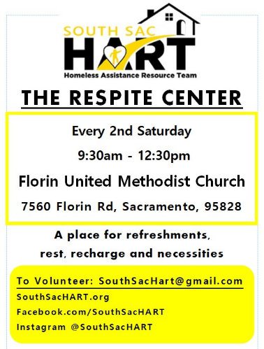

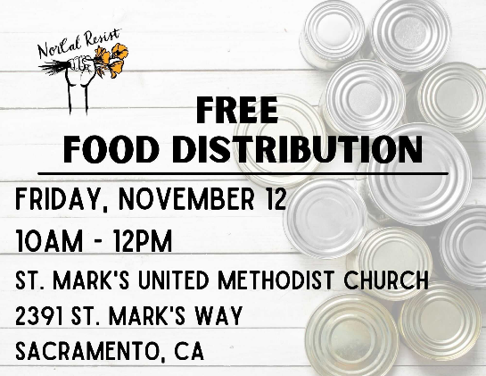

FRIDAY, NOVEMBER 12, 2021, AT 10 AM – 12 PM

Free Food Distribution! Comida Gratis!

We will be out with non-perishable boxes of food from the Sacramento Food Bank. Drive through line. No ID necessary, just show up!

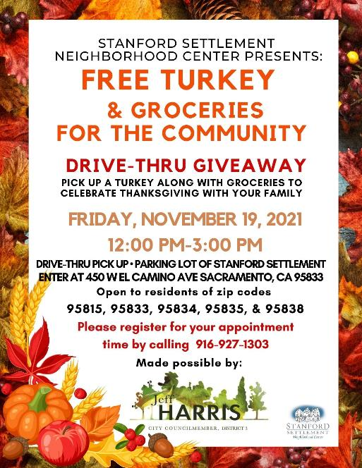
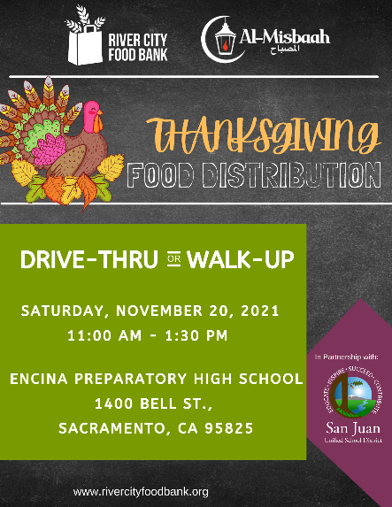

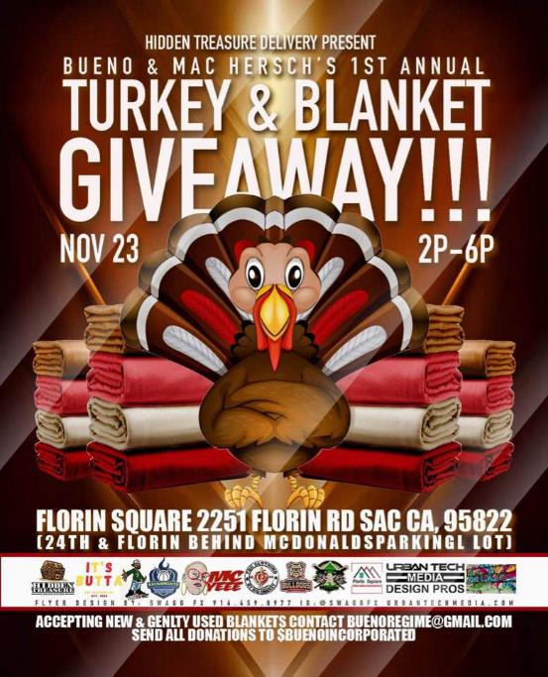
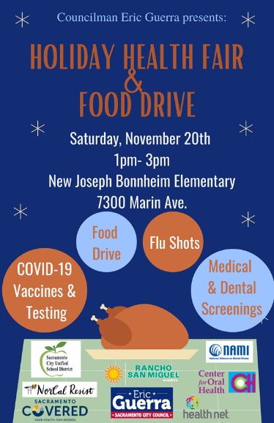
Need food, flu/ COVID vaccines or health screenings?
Join us Saturday November 20th at our Holiday Health Fair and Food Drive at New Joseph Bonnheim Elementary!
We will have COVID-19 Vaccinations and testing, a Food Drive with Turkeys and more, Flu shots as well as medical and dental screenings!
Please reach out to 916-808-7006 for questions.

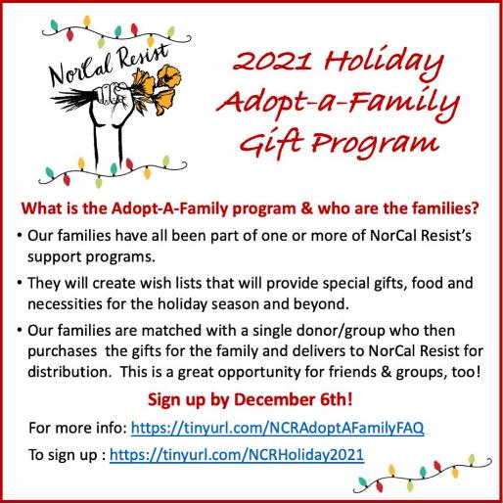
Our holiday program is so much fun. Don’t miss out! Sign up at tinyurl.com/NCRHoliday2021

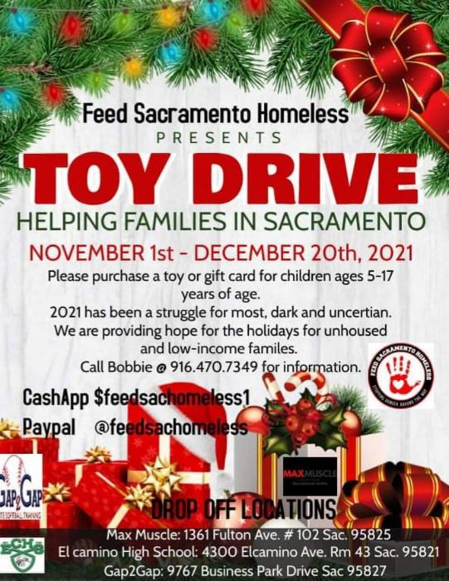

Holiday Resource List is compiled by Sacramento Poor People’s Campaign, Sacramento Homeless Organizing Committee, and Sacramento Area Black Caucus November 2021

